Effectiveness of Belleville Washers for Seismic Retrofit of Substation Equipment
Experimental and analytical research conducted at the University at Buffalo
InsertSAPNumberHere

Effectiveness of Belleville Washers for Seismic Retrofit of Substation Equipment
Experimental and analytical research conducted at the University at Buffalo
InsertSAPNumberHere
Technical Update, March 2024

EPRI Title Page Should Include:
  - Title: A maximum of 90 characters or less (including spaces) is recommended. Acronyms and abbreviations should be avoided.
  - Subtitle: Strongly advised. A maximum of 150 characters including spaces is recommended for the title and subtitle together.
  - Product ID Number
  - Type of Report: Technical Update.
  - Publication Date: The month and year that the report is published.
  - EPRI Project Manager: First initial and last name.
Blue boxes are for information only and should be deleted.

DISCLAIMER OF WARRANTIES AND LIMITATION OF LIABILITIES
THIS DOCUMENT WAS PREPARED BY THE ORGANIZATION(S) NAMED BELOW AS AN ACCOUNT OF WORK SPONSORED OR COSPONSORED BY THE ELECTRIC POWER RESEARCH INSTITUTE, INC. (EPRI). NEITHER EPRI, ANY MEMBER OF EPRI, ANY COSPONSOR, THE ORGANIZATION(S) BELOW, NOR ANY PERSON ACTING ON BEHALF OF ANY OF THEM:
(A) MAKES ANY WARRANTY OR REPRESENTATION WHATSOEVER, EXPRESS OR IMPLIED, (I) WITH RESPECT TO THE USE OF ANY INFORMATION, APPARATUS, METHOD, PROCESS, OR SIMILAR ITEM DISCLOSED IN THIS DOCUMENT, INCLUDING MERCHANTABILITY AND FITNESS FOR A PARTICULAR PURPOSE, OR (II) THAT SUCH USE DOES NOT INFRINGE ON OR INTERFERE WITH PRIVATELY OWNED RIGHTS, INCLUDING ANY PARTY'S INTELLECTUAL PROPERTY, OR (III) THAT THIS DOCUMENT IS SUITABLE TO ANY PARTICULAR USER'S CIRCUMSTANCE; OR
(B) ASSUMES RESPONSIBILITY FOR ANY DAMAGES OR OTHER LIABILITY WHATSOEVER (INCLUDING ANY CONSEQUENTIAL DAMAGES, EVEN IF EPRI OR ANY EPRI REPRESENTATIVE HAS BEEN ADVISED OF THE POSSIBILITY OF SUCH DAMAGES) RESULTING FROM YOUR SELECTION OR USE OF THIS DOCUMENT OR ANY INFORMATION, APPARATUS, METHOD, PROCESS, OR SIMILAR ITEM DISCLOSED IN THIS DOCUMENT.
Reference herein to any specific commercial product, process, or service by its trade name, trademark, manufacturer, or otherwise, does not necessarily constitute or imply its endorsement, recommendation, or favoring by EPRI.
The following organization(s), under contract to EPRI, prepared this report:

If EPRI prepared the report, please use the following line in place of the last two lines of the above disclaimer:
THE ELECTRIC POWER RESEARCH INSTITUTE (EPRI) PREPARED THIS REPORT.
Blue boxes are for information only and should be deleted.

If this is a Nuclear Power report, insert the appropriate Nuclear Power Disclaimer Auto Text entry here.
Blue boxes are for information only and should be deleted.

This is an EPRI Technical Update report. A Technical Update report is intended as an informal report of continuing research, a meeting, or a topical study. It is not a final EPRI technical report.

NOTE
For further information about EPRI, call the EPRI Customer Assistance Center at 800.313.3774 or
e-mail askepri@epri.com.
Electric Power Research Institute, EPRI, and TOGETHER…SHAPING THE FUTURE OF ELECTRICITY are registered service marks of the Electric Power Research Institute, Inc.
Copyright © 2019 Electric Power Research Institute, Inc. All rights reserved.

Acknowledgments
The following organization(s), under contract to the Electric Power Research Institute (EPRI), prepared this report:
University at Buffalo
212 Ketter Hall
Buffalo, NY 14260
Principal Investigator
M. V. Sivaselvan
Note: if EPRI prepared the report, please replace the above text with the following. Otherwise please delete.
The Electric Power Research Institute (EPRI) prepared this report.
Principal Investigator
I. Last
Blue boxes are for information only and should be deleted.

This report describes research sponsored by EPRI. <In most cases, reports should indicate EPRI only as the “sponsor.” If there is a desire to acknowledge funders, insert the following sentence: EPRI would like to acknowledge the support of the following organizations: [list]>.
Insert any additional acknowledgment statements here.

Abstract
Preparation Guidelines
The Abstract is a PUBLIC summary of the report that highlights the objectives of the reported research. It briefly describes the steps taken to conduct the work and summarizes the results and any potential applications. This section may be called “Product Description” as desired by the author.
  - REQUIRED section.
  - Because it is public and available on www.epri.com, it must not contain any confidential, proprietary, or trade secret information belonging to EPRI or to any other party, or any information subject to Export Control.
Blue boxes are for information only and should be deleted.

Type Abstract text here.
Keywords
Identify a list of keywords that would be useful in helping domestic and international customers search for information or locate the report on EPRI.com. Please use a maximum of six keywords.

Deliverable Number: InsertSAPNumberHere
- Exec. Summary is an OPTIONAL section for Technical Updates.
- If used, section will be made available as a standalone download, and also be retained within full report.
- Download of Exec. Summary is accessible to funders only.
Blue boxes are for information only and should be deleted.
Product Type: Technical Update
Product Title: Effectiveness of Belleville Washers for Seismic Retrofit of Substation Equipment: Experimental and analytical research conducted at the University at Buffalo

Primary Audience: Identify primary end user of this research
Secondary Audience: Identify a secondary end user, if applicable
KEY RESEARCH QUESTION
Concise statement (no more than a few sentences) describing the main issue or research question. This section should answer why this R&D was conducted. Length: 3-4 sentences.
RESEARCH OVERVIEW
Briefly describe what was done in this research, how it was done and the form of the research results. Length: one paragraph, 5 – 6 sentences.
KEY FINDINGS
- Pull out the 4-6 major findings and conclusions from the report.
- For software: pull out 4-6 key aspects of the software, use examples.
- Share the key “nuggets” from the report/product.
- Note that only people who have access to the subject report (by virtue of membership, funding, or free public access) will have access to this summary, so findings should be specific.
- Best practice: Use bullets and include references and links to specific locations/sections in the report.
WHY THIS MATTERS
Research Value: clearly explain the value that members are receiving from the research or product. Written to a general member audience that covers advisors, end-users, and senior management. Length: 2-3 sentences.

HOW TO APPLY RESULTS
Include information here that would help the end-user implement the research product. This might be platform requirements for software, reference to a quick start guide to rapidly derive value from the product, guidance on which internal/external stakeholders the user should engage to improve changes for success, etc. Length: 2-3 sentences.
LEARNING AND ENGAGEMENT OPPORTUNITIES
- If applicable, list other projects, supplemental activities (such as user groups), software, webcasts/workshops, etc. that the end-user should be aware of to optimize the value received. Provide links if available.
- Who might be interested in this product? Any collaborating Organizations, Agencies, Sectors, or Programs on this deliverable?
EPRI CONTACTS: Insert PM Name, Title, Email
Program: Add Program Name and Number here.
Implementation Category: Add Nuclear Product Implementation Category here.

Additional Front Matter Section(s)

User Defined Sections Can Include:
- Acronyms and Abbreviations, Nomenclature, Definitions, etc.
- If the final report contains or describes patentable inventions or discoveries, a Patents Page should be included in the Front Matter. This page should describe the invention or discovery and indicate where it can be found in the report.
Blue boxes are for information only and should be deleted.

To create additional Front Matter sections such as this, place the cursor to the left of the paragraph mark at the beginning of the previous Section Break format marker, select Insert Break, choose Section Break Types Odd Page.
Type the desired Front Matter Section Title and hit Return twice. Highlight the Front Matter Section Title and apply Section Title Only Style.
Place the cursor to the left of the second paragraph mark, begin typing text, then apply EPRI Normal Style to the text.
Subheading (apply EPRI Subheadings Style)
Any subheadings created in Front Matter Sections must be styled with EPRI Subheadings Style.
To delete this section, highlight the Section Title through and including the section break below and hit the Delete key.

Contents
ABSTRACT V
EXECUTIVE SUMMARY VII
1 Introduction 1-1
Background and objectives 1-1
Nomenclature for washer configurations 1-4
Analysis and design questions 1-5
Organization of the report 1-6
2 Proposed analysis procedure 2-1
3 Cyclic force-displacement behavior of washer stacks 3-1
4 Shake table experiments 4-1
Test setup 4-1
Instrumentation 4-1
Determination of CVT inertia properties 4-4
Washer stack installation 4-5
Test configurations and protocol 4-5
Correlating measured forces and accelerations 4-6
5 Nonlinear modeling and analysis 5-1
From stack force-displacement to system moment-rotation 5-1
Modeling moment-rotation hysteresis 5-2
Summary of nonlinear dynamic model 5-3
Analysis results 5-3
6 Equivalent linear modeling 6-1
Identifying equivalent frequency and damping ratio from measurements 6-1
Graphical determination of equivalent stiffness and damping ratio 6-1
Response-spectrum interpretation 6-1
7 Comparison with ASCE-7 procedures for base isolation 7-1
8 Summary and concluding remarks 8-1
Recommended analysis and design procedure 8-1
Outstanding research questions 8-1
9 REFERENCES 9-1

List of Figures
Figure 1-1 Belleville washer shape, dimensions and stack consisting of series-parallel arrangement 1-1
Figure 1-2 Force-displacement response of a single washer as a function of h/t (source [7]) 1-2
Figure 1-3 Capacitive voltage transformer (CVT) provided by Seattle City Light and used in shake table experiments described in Chapter 4. 1-5
Figure 3-1 Washer stack force-displacement response measurement by compressing the stack directly in the materials testing machine; force-displacement response exhibits unexpected changes in slope. 3-1
Figure 3-2 Washer stack force-displacement response measurement by compressing the stack through a loading frame with guiding rod; this is closer to how to washers are mounted under the equipment, and the force-displacement response is clean. 3-2
Figure 3-3 Measured force-displacement curves for two configurations. The legend MTS denotes measurement from the materials testing machine through the frame with guiding rod. The other curves are in situ measurements from the shake table a different preload levels. The in situ measurements follow the testing machine results closely, confirming that the washer stack response can be characterized fully using simply a materials testing machine. 3-2
Figure 3-4 Measured force-displacement curves for two configurations with the K1750-J-057 washers. They have a softening behavior because of their larger h/t ratio (cf. Figure 1-2) 3-3
Figure 4-1 CVT mounted on shake table 4-1
Figure 4-2 Instrumentation details 4-2
Figure 4-3 Details of Load Washer Alternate (LWA) and preloading process 4-3
Figure 4-4 CVT mounted on springs to estimate mass moment of inertia indirectly from measured frequency 4-4
Figure 4-5 Acceleration measured when CVT is mounted on springs and the resulting frequency fit, and process to compute CVT mass moment of inertia from measured frequency; the dimension b is 6.375in in the X direction and 9.25in in the Y direction. 4-4
Figure 4-6 5%-damped test response spectra of applied CERL motion compared with required response spectrum 4-5
Figure 4-7 Free body diagram with mid-spool cut 4-6
Figure 4-8 Correlation between the independent measurements, $M\text{spool}$ and $-I0θ-mx\text{t}L$, demonstrating consistency for the 2 units of 2U2D configuration under 0.5g CERL motion in the X direction. 4-7
Figure 4-9 Free body diagrams relating moment measured at the spool with moment estimated using LWAs 4-8
Figure 4-10 Free body diagram used to relate insulator base moment to measured accelerations; L₁ is the mid-height of the insulator, L₁ = in; L₂ = the distance from the center of rotation to the center of mass of the insulator, L₂ = in. 4-9
Figure 4-11 Correlation between $M\text{spool}$ and $MCVT$per equation (4-6) demonstrating consistency for the 2 units of 2U2D configuration under 0.5g CERL motion in the X direction. 4-10
Figure 4-12 Measured insulator base moment for the different configurations for 0.5g CERL motion applied in the X direction 4-12
Figure 4-13 Measured insulator base moment for the different configurations for 0.5g CERL motion applied in the Y direction 4-13
Figure 5-1 Process to obtain moment-rotation behavior from washer-stack force displacement behavior 5-1
Figure 5-2 Example of constructing the moment-rotation behavior from the stack force-displacement behavior for 2 units of 2U2D. 5-1
Figure 5-2 Parallel decomposition of moment-rotation behavior into elastic and hysteretic components (example shown for 2 units of 2U2D). 5-2
Figure 5-2 Comparison on model and measured moment-rotation behavior when the model is driven by the measured θ_{w} as input (example shown for 2 units of 2U2D). 5-3

No table of figures entries found.

List of Tables
Table 1-1 Washers used in this project [22] 1-4
Table 1-2 Nomenclature used for Belleville washer units and stacks 1-4
Table 4-1 Summary of measured response quantities and corresponding instruments 4-2
Table 4-2 Response quantities derived indirectly from measurements 4-3
Table 4-3 Summary of CVT inertia properties 4-4
Table 4-4 Summary of configurations tested 4-5
Table 4-5 Summary of CVT inertia properties 4-6

No table of figures entries found.

Introduction

Background and objectives
Base isolation and supplemental damping systems are now widely used as seismic protective systems in structures. They represent a design philosophy that seeks to reduce seismic demand on functional structural components, and to minimize if not eliminate damage and permanent deformation even under large earthquakes. This is in contrast to the conventional seismic design philosophy, wherein structural components are designed to be ductile, and undergo permanent deformation without failure. For critical structures and equipment, such as in electrical substations, the approach of reducing seismic demand and permanent deformations is more attractive to ensure continued functioning of such structures and equipment post-earthquake. The concept of frequency modification for substation equipment was recommended as early as 1973 in a report prepared for Bonneville Power Administration (BPA) [1]. Base isolation and supplemental damping systems are being increasingly deployed in substations for seismic protection [2-5].
One approach to modifying frequency and adding damping is using stacks of Belleville washers. Belleville washers, named after Julian Belleville, who patented them in 1867, are circular washers given a taper to form a conical shape (Figure 1-1a). They are also known as a disc springs or conical spring washers, although the term “disc springs” may be more appropriate [6] for the type of dynamic application considered in this report. When a compressive load is applied along the axis, the washer flattens by way of elastic deformation, resulting in spring action [7]. When washers are nested such that the bottom surface of one is placed on the top surface of the next, frictional rubbing between these surfaces results in hysteretic behavior (see Chapter 3), and
(a) Shape and dimension specifications (source: [7]) | 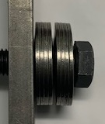  (b) Example of a stack with series-parallel arrangement
Figure 1-1
Belleville washer shape, dimensions and stack consisting of series-parallel arrangement
hence energy dissipation. The washers can also be stacked in different ways as illustrated in Figure 1-1 and Table 1-2. Thus the stiffness and dissipation of a stack of Belleville washers can be tuned. Testing discussed further in Chapter 3 has shown that the force-displacement hysteresis of washer stacks is stable and repeatable. These stacks therefore lend themselves to modeling, and use as engineered frequency modification and energy dissipation devices.
For early analyses of the mechanical behavior of Belleville washers, see [8, 9], considering both single washer and nesting. For a more recent study on the analysis of washer mechanical behavior, see [10] and the references therein. The force-displacement behavior of a single washer is given by [7, 9]
$F=\frac{Eδ}{(1-μ^2)Ma^{2}}\left[(h-δ)\left(h-\frac{δ}{2}\right)t+t^3\right]$ (1-1)
where F and δ are the force in the washer and deflection, E and μ are the Young’s modulus and Poisson ratio of the washer material, M is a constant that depends on the ratio of outer to inner diameters (see [7] for a chart), a is the outer radius and h and t are the dimension shown in Figure 1-1. Depending on the h/t ratio, equation (1-1) implies a wide variety force-displacement behaviors as shown in Figure 1-2. As a point of reference, the washers used in the present project are listed in Table 1-1. The K1875-G-086 washer has a h/t ratio of 0.5, which corresponds to almost linear behavior till flattening. The K1750-J-057 washer on the other hand has a h/t ratio of 1.0 resulting in a force-displacement curve that softens significantly before flattening. These behaviors are reflected in the test results in Chapter 3. Specific features of the force-displacement behavior can be exploited. An even wider range of behavior has been explored using Belleville-washers made of shape-memory materials [12].
Figure 1-2
Force-displacement response of a single washer as a function of h/t (source [7])
Belleville washers have been used in a number of industries for vibration isolation/absorption applications (see for example [13]). This includes seismic protective systems. Used of large Belleville washers (referred to therein as coned disc springs) for vertically isolation of the reactor vessel and other components in a horizontally isolated nuclear power plant building was discussed in references [14-16]. Belleville washers have been used to maintain bolt tension in frictional sliding structural connections [17]. Shape memory Belleville washers have also been considered for energy-dissipating braces in structures [18]. The closely related concept of ring springs has been studied for seismic isolation in [19]. Use of Belleville washers for vertical isolation of buildings under train-induced vibration has been studied in [20]; in this paper, the different force-displacement responses of Figure 1-2 are properly utilized and a thorough analysis of hysteretic behavior (cf. Chapter 3 in this report) is presented.
The first suggestion of using Belleville washers for seismic protection of substation equipment was in a report prepared for Bonneville Power Administration [1]. The suggestion was made in the context of lightning arresters. The 1984 edition of IEEE 693 [21] briefly mentions the possibility of Belleville washers for seismic protection, but this was removed in subsequent edition. Seattle City Light has been installing Belleville washer stacks for seismic protection of their equipment; the present research was driven by this.
The goal of this project is to study the effectiveness of Belleville washers for seismic protection of equipment such as capacitive voltage transformers (CVT), capacitor banks etc. that do not have moving parts (such as in switches) and do not have complex dynamic modes of their own (such as dead tank circuit breakers). Such equipment, when mounted on support structures, essentially behave as rigid bodies rocking under horizontal ground motion due to the flexibility of the support structure. When Belleville washer stacks are installed at the base of such equipment, above the support structure, the equipment will rock under horizontal ground motion relative to the support structure. The Belleville washer stacks are expected to provide damping through frictional dissipation under such motion, resulting in reduction of equipment base moment relative when they are rigidly connected to the support structure. In deforming to provide frictional dissipation, the washer stacks will also invariably reduce the frequency; this reduction may further aid in reducing base moment. This could potentially occur at the expense of increased terminal deflection that must be accommodated.
The objectives of this project are:
- Develop an analysis-based systematic approach for design of a Belleville-washer seismic protective system for a given equipment (together with given seismic demand and support structure).
- Develop support for such an approach through physical experiments.
A CVT provided by Seattle City Light (see ) is used in the shake table experiments described in Chapter 4.

Nomenclature for washer configurations
The specific washers used in the project are from Key Bellevilles [22] and are listed in Table 1-1.
Table 1-1
Washers used in this project [22]
Washer | Outer Diameter (in) | Inner Diameter (in) | t (in) | h (in) | Flattening load (lb)
K1875-G-086 | 1.875 | 0.656 | 0.086 | 0.043 | 1319
K1750-J-057 | 1.750 | 0.88 | 0.057 | 0.057 | 650

Table 1-2 summarizes the nomenclature used in this report for Belleville washer units, each consisting of series parallel arrangements. A stack is identified by the number and type of units, for example as illustrated in Table 1-2.
Table 1-2
Nomenclature used for Belleville washer units and stacks
Units |  |  | Stack
 | Configuration | Nomenclature | Example: Stack consisting of 2 units of 2U2D
1 |  | 1U
2 |  | 1D
3 |  | 1U1D
4 |  | 2U2D
5 |  | 3U3D
Then washers are nested with the cones oriented in the same direction, as for example in the top or bottom half of a 2U2D unit, they act in parallel since when a load is applied, their deformations are the same. When the cone orientations are opposite, as for example with the two washers in a 1U1D unit, they are in series, since they see the same force and their deformations are additive. Thus, a stack can be viewed as a series-parallel arrangement of washers. If the washers were ideal springs, the stiffness of a stack can be calculated using series-parallel combinations of the stiffnesses of the constituent springs (as will be seen in Chapter 3, washers, particularly when nested are not linear springs and exhibit hysteresis, so such a calculation of stiffness would only be approximate). The strength (flattening load) of a stack is determined by the weakest parallel combination in the stack.
Figure 1-3
Capacitive voltage transformer (CVT) provided by Seattle City Light and used in shake table experiments described in Chapter 4.

Analysis and design questions
The findings reported here must ultimately guide the selection of washer stacks the provide the desired level of seismic protection. This is the design question, given (a) an equipment, (b) its support structure, (c) seismic input (design spectrum) and (d) performance specifications (max base moment, max terminal displacement etc.), design a Belleville washer stack so that the system response meets the specifications.
A prerequisite to approaching this design question is being able to answer the analysis question, given (a) an equipment, (b), its support structure, (c) seismic input (ground motion record) and (d) a specific Belleville washer configuration, compute the response of this system (accelerations, base moments, terminal displacements etc.). Hence the emphasis of this project is more on this analysis question and support for the analysis process from physical experimental measurements, with a focus as noted above on “rigid” structures, in particular a CVT.

Organization of the report
This report is organized as follows. As noted above, the main goal of this project is to develop an analysis-based systematic approach for design of a Belleville-washer seismic protective system. The report is therefore structured around an analysis procedure. This procedure is summarized upfront in Chapter 2, and the various steps in this procedure are expounded in subsequent chapters. Characterizing the force-displacement hysteresis of a single stack of washers through cyclic loading tests is presented in Chapter 3. Shake table experiments to characterized dynamic seismic response of a CVT equipment with Belleville washer stacks, including setup, instrumentation and specific steps for installing the washer stacks, are described in Chapter 4. In Chapter 5, a nonlinear dynamic model of the CVT with Belleville washer stacks is developed, and predictions from the model are compared with measurements from shake table experiments. An important note is that all the information needed for this model can be obtained from the washer characterization data from Chapter 3, the type of information that can be readily obtained. In Chapter 6, a linearized model based on equivalent stiffness and damping is developed that may be more conducive for practical use than the nonlinear model in Chapter; 5 this linear model can also be developed simply for the characterization data in Chapter 3. Chapter 7 is a brief comparison of the approach taken in this report to analyze substation equipment with Belleville washer seismic protective systems to that in ASCE 7 for seismically isolated structures; this comparison is to lend credence to the proposed approach relative to well-established procedures in seismic standards. Finally in Chapter 8, a summary is provided, and some outstanding questions are identified.

Proposed analysis procedure
The main goal of this project is to develop an analysis-based systematic approach for design of a Belleville-washer seismic protective system. Therefore, in this chapter, a proposed analysis procedure is laid out. This serves to tie together the different steps and experimental support for these steps discussed in subsequent chapters. The following is the proposed analysis procedure:
Given (a) an equipment, (b) its support structure, (c) seismic input (ground motion record), (d) Belleville washer configuration
- Determine the force-displacement response of the stack.
  - In this project, we have done this by testing the stack in a material test machine (see Chapter 3).
  - This is a hysteretic behavior.
- Compute the moment-rotation behavior of the assembly of washer stacks (see Chapter 5).
  - This can be done, for example, in an Excel spreadsheet.
  - In this project, special instrumentation has been used to experimentally verify the relationship between the stack force-displacement behavior and the system moment-rotation behavior (see Chapter 4).
- Model this moment-rotation behavior – two possible approaches.
  - Fit a hysteresis model (Chapter 5).
  - Compute an “equivalent” stiffness and damping (Chapter 6).
  - Both approaches have been verified in this project; it has also been verified that this equivalent stiffness and damping agrees well with fitting a linear model to the measured response.
- Compute the system response – three approaches are possible.
  - Nonlinear time-history analysis with the hysteresis model for the washer arrangement (Chapter 5).
  - Linear time history analysis with the equivalent stiffness and damping.
  - Response spectrum analysis with the equivalent stiffness and damping ((Chapter 6). This together with the equivalent stiffness and damping resemble ASCE 7 process for base isolation (Chapter 7).
  - In the project, it has been verified that the three approaches produce close responses

Cyclic force-displacement behavior of washer stacks
This chapter is on the measurement of force-displacement behavior of Belleville washer stacks. As will be seen in Chapters 5 and 6, this is the primary information required to predict the seismic response of rigid equipment (besides mass, moment of inertia of the equipment itself and support structure stiffness).
The force displacement response of a washer stack is obtained here by applying cyclic compressive loading to the stack in a materials testing machine. At first, this was done by simply compressing the stack between loading plates as shown in Figure 3-1(a). The resulting force-displacement curves of Figure 3-1(b) showed changes in slope that weren’t observed in force-displacement measurements of the same stack in shake table tests (the special instrument designed to measure this response in situ under the equipment in the shake table test is discussed in Chapter 4). This is likely because of slight misalignment between washers in the stack initially that corrects itself during the loading. To avoid this, an alternative approach was devised, where the compressive loading was applied to the stack through a loading frame and guiding rod as illustrated in Figure 3-2(a). This arrangement is closer to how the washer stack is installed under the equipment. The guiding rod prevents any initial misalignment and subsequent realignment. The resulting force-displacement measurement, shown in Figure 3-2(b), does not have any unexpected changes in slope. Indeed the in situ measurements from the shake table tests follow these curves closely as seen in Figure 3-3.
(a) Washer stack compressed directly between loading plates | (b) Measured force-displacement hysteresis
Figure 3-1
Washer stack force-displacement response measurement by compressing the stack directly in the materials testing machine; force-displacement response exhibits unexpected changes in slope.
(a) Washer stack compressed through a loading frame with guiding rod | (b) Measured force-displacement hysteresis
Figure 3-2
Washer stack force-displacement response measurement by compressing the stack through a loading frame with guiding rod; this is closer to how to washers are mounted under the equipment, and the force-displacement response is clean.
(a) 2 units of 2U2D K1875-G-086 | (b) 3 units of 3U3D K1875-G-086
Figure 3-3
Measured force-displacement curves for two configurations. The legend MTS denotes measurement from the materials testing machine through the frame with guiding rod. The other curves are in situ measurements from the shake table a different preload levels. The in situ measurements follow the testing machine results closely, confirming that the washer stack response can be characterized fully using simply a materials testing machine.
Figure 3-4 shows force-displacement curves for two configurations of the K1750-J-057 washers. They exhibit the reduction in stiffness with loading noted in Figure 1-2 due to their higher h/t ratio.
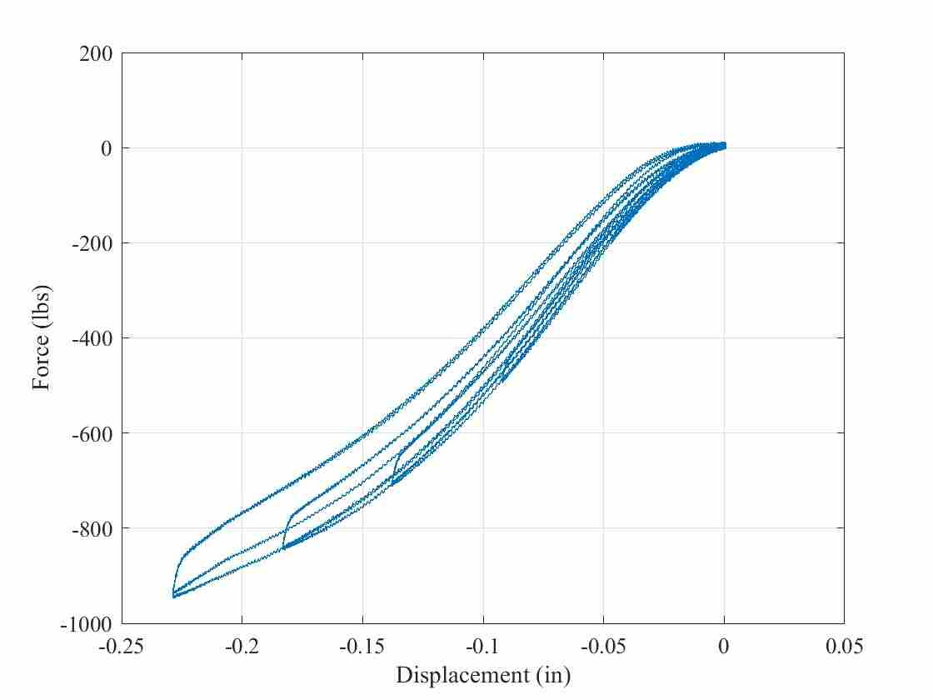 | 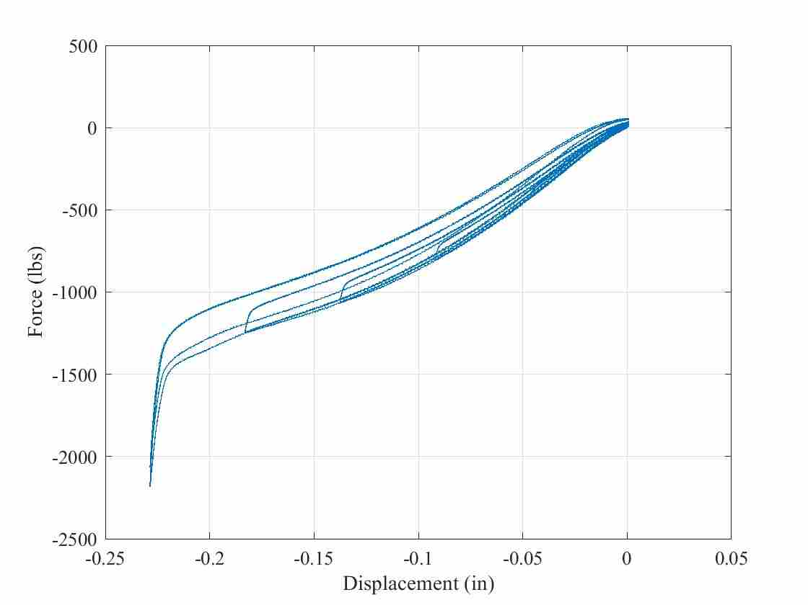
(a) 2 units of 2U2D K1750-J-057 | (b) 2 units of 3U3D K1750-J-057
Figure 3-4
Measured force-displacement curves for two configurations with the K1750-J-057 washers. They have a softening behavior because of their larger h/t ratio (cf. Figure 1-2)

Shake table experiments
In this chapter, shake table experiments on the CVT equipped with Belleville washer stacks are described. The experimental setup, instrumentation, and washer installation process are detailed. The primary purpose of these experiments is to obtain measurements in support of the analysis procedure outlined in Chapter 2. Consequently, special instruments were used to measure the washer response in situ. Instrumentation was also designed with redundancy in mind, so that the same quantity is measured by multiple means and can be cross-checked. Some other checks such as sums of forces are moments are perform to confirm the integrity of the measurements.

Test setup
Figure 4-1 shows the CVT mounted on the shake table. The CVT is mounted on a pedestal referred to as the “spool”, which in turn is mounted on the shake table. The spool consists of a 10-in diameter ½-in thick 16.5-in tall steel tube with a 22in×17 steel plate welded on top (to match the base dimensions of the CVT). Figure 4-1 also shows the direction convention X along the East-West direction, Y along the North-South direction and Z along the vertical direction. The distance between the mounting holes at the base of the CVT is greater in the Y direction than in X direction (resulting, for example, in the Y frequency direction than in the X direction). The Belleville washer stacks are installed between the CVT base and the spool, details of which are elaborated below.
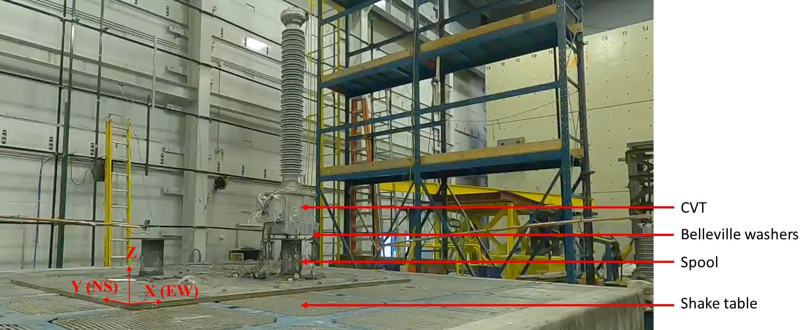
Figure 4-1
CVT mounted on shake table

Instrumentation
An overview of response quantities measured and corresponding instrumentation is provided in Figure 4-2. Table 4-1 contains a detailed summary. In addition to these response quantities that are measured directly, further response quantities are derived indirectly from them. These quantities as well as the process used to derive them are summarized in Table 4-2. A specialized instrument in Table 4-1, designed in this project to measure the force in a washer stack in situ is
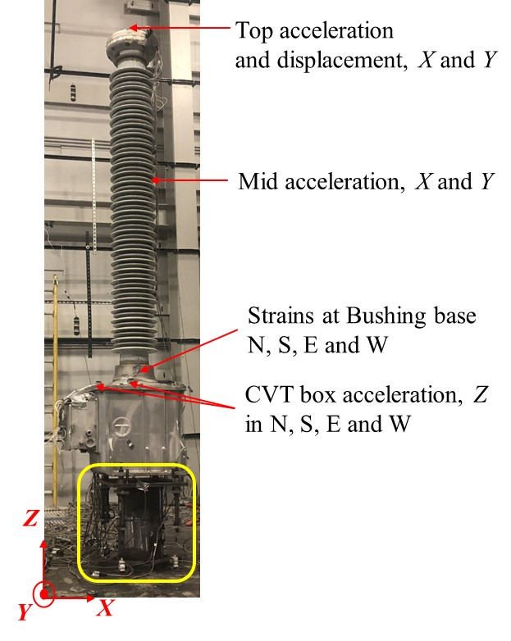 | 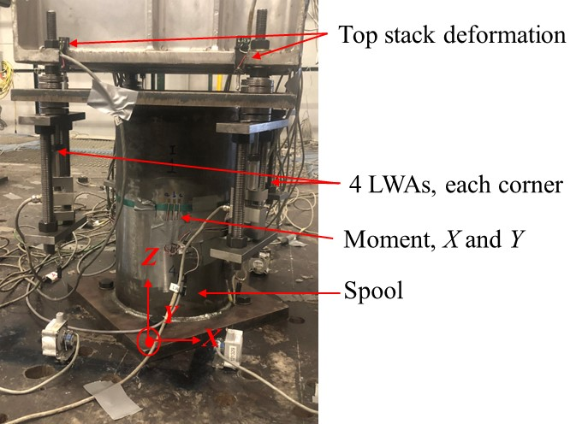
(a) Summary of instruments | (b) Closeup of yellow box in (a)
Figure 4-2
Instrumentation details
Table 4-1
Summary of measured response quantities and corresponding instruments
 | Response quantity | Instrument
1 | Top X and Y displacement components | String potentiometers attached to frames outside the shake table, so these measure absolute displacements
2 | Top X and Y acceleration components | One 3D accelerometer
3 | X and Y accelerations at insulator mid-height | Two 1D accelerometers
4 | Z accelerations at N,S,E,W locations on CVT box | Four 1D accelerometers
5 | Insulator base moment | Strain gages at N,S,E,W locations at insulator base, calibrated to measure base moment
6 | Displacements at 4 locations of the base of the CVT relative to the spool plate | Four linear potentiometers
7 | Tension forces in rods going through the four washer stacks | Four specially designed instruments called “load washer alternates” LWAs (see below)
8 | Two bending moment components in the spool (M_{spool}) | Two full-bridge strain gage circuits, one for X bending moment and the other for Y
9 | Shake table accelerations | Accelerometers
10 | Shake table displacements | String potentiometers

Table 4-2
Response quantities derived indirectly from measurements
 | Derived response quantity | Symbol* | Method of computation
i | Rigid-body translational and rotational acceleration of CVT at center of mass | ${\ddot{x}}_{t}$, $\ddot{θ}$ | Linear fit to acceleration components rows 2—4 in Table 4-1. A good fit here demonstrates the CVT can be idealized as a rigid body.
ii | Total rotation of CVT | $$θ$$ | Linear fit to CVT displacements (row 1) and shake table displacements (row 10) in Table 4-1
iii | Rotation of CVT relative to spool plate | $$θ_{\text{w}}$$ | Linear fit to displacements in row 6 of Table 4-1
iv | Restoring moment generated by washer stacks (and spool plate) | $$M_{\text{CVT}}$$ | Twice the moment computed from the four LWAs (row 7 of Table 4-1, see Figure 4-3 for details)
v | Deflection of spool plate | - | Difference of rows ii and iii above
* the symbols listed here are in reference to dynamics in the X East-West direction, corresponding quantities in the Y North-South direction will be labeled similarly, but not shown here

the Load Washer Alternate (LWA) shown in Figure 4-3. It consists of a frame made of a frame consisting of two plates and two ¾-in threaded rods. The guiding rod of the Belleville washer stacks goes through a hole in the top plate, and connects to a load cell attached to the bottom plate. When the washer stack right above the top plate is compressed, the guiding rod develops tension that is measured by the load cell. Thus the load cell measures the compression in the Belleville washer stack below the spool plate.
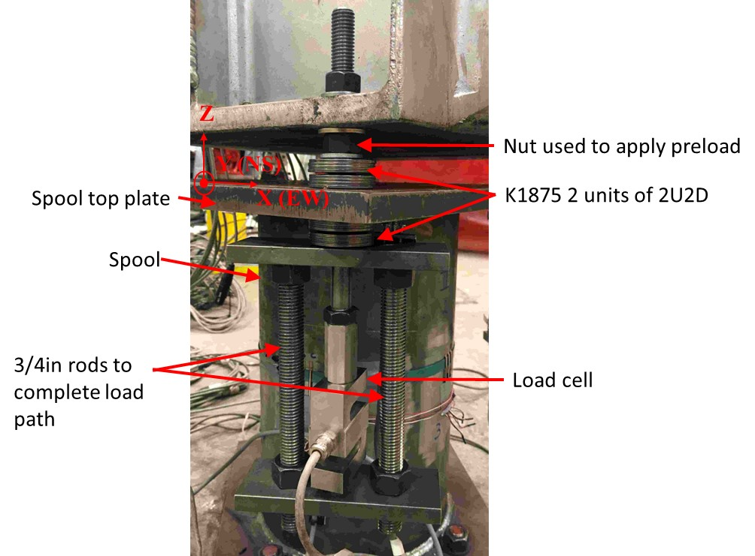
Figure 4-3
Details of Load Washer Alternate (LWA) and preloading process

Determination of CVT inertia properties
For further analysis, the mass, mass moment of inertia and center of mass position of the CVT must be determined. The mass is obtained simply from the measured weight. The center of mass position is determined by balancing the CVT horizontally using a crane. The mass moment of inertia is computed from the frequency measured by mounting the CVT on springs of known stiffness (Figure 4-4) using the method outlined in Figure 4-5. A summary of the inertia properties of the CVT is shown in .
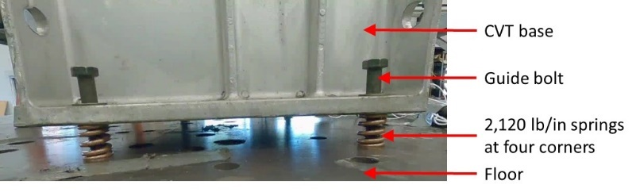
Figure 4-4
CVT mounted on springs to estimate mass moment of inertia indirectly from measured frequency
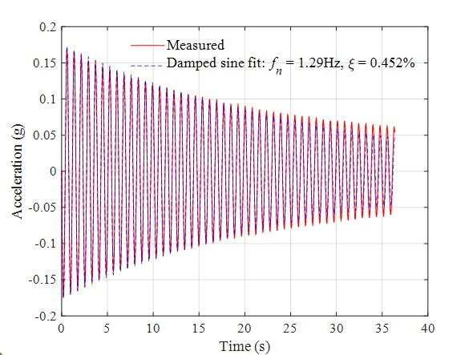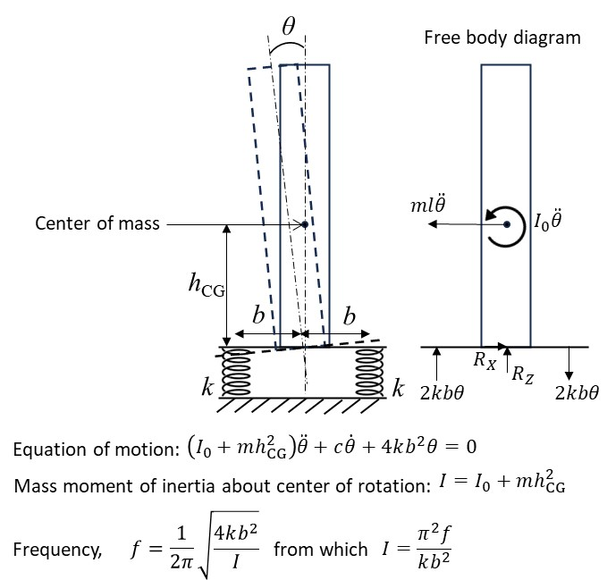
Figure 4-5
Acceleration measured when CVT is mounted on springs and the resulting frequency fit, and process to compute CVT mass moment of inertia from measured frequency; the dimension b is 6.375in in the X direction and 9.25in in the Y direction.
Table 4-3
Summary of CVT inertia properties
Parameter | Description | Value
m | Mass | 940/386.4 lb-s²/in
h_{CG} | Height of center of mass from CVT base | 35-1/16 in
I | Mass moment of inertia about center of rotation | 5,500 lb-s²-in
I₀ | Mass moment of inertia about center of mass | 2,500 lb-s²-in

Washer stack installation
Special care is exercised in controlling the preload when installing the Belleville washer stacks. The stacks are installed on the spool plate with out the CVT present. The stacks at each corner are preloaded independently by tightening the nut at the top (Figure 4-3) by a prescribed number of turns corresponding to fraction of flattening displacement targeted in the washer stacks. The force in the bottom stack is simultaneously monitored using the LWA to make sure that the load corresponds to the stack deflections in accordance with the force-deformation relationship measured in the tests described in Chapter 3. The CVT is then seated on the four top nuts, and fixed in place using four nuts above the CVT base plate.

Test configurations and protocol
Pull tests were performed in the X and Y directions with the CVT fixed directly to the spool plate to calibrate to the bending moment load cells in the spool and the strain gages at the insulator base to bending moment.
The washer configurations shown in Table 4-4 were tested. All configurations were double acting – there were washer stacks above and below the spool plate.
Table 4-4
Summary of configurations tested
Washer type | Configuration | Pre-load (% of flattening)
K1875-G-086 | 2 units of 2U2D | 0 lb (0%)
 |  | 500 lb (25%)
 |  | 1,000 lb (50%)
 | 3 units of 3U3D | 500 lb (17%)
 |  | 1,500 lb (50%)
For each configuration, a sequence of tests consisting of low-level broad-band random input (for baseline system identification) and the CERL ground motion with increasing amplitude levels (culminating at 0.5g) were applied first in the X direction and then in the Y direction. The 5%-damped test response spectra of the applied motion are shown in .
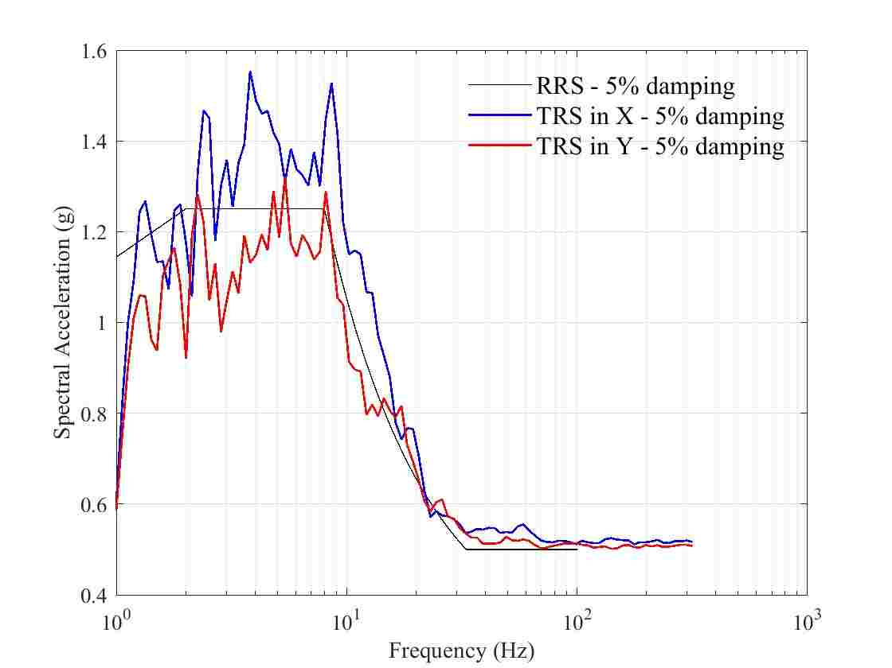
Figure 4-6
5%-damped test response spectra of applied CERL motion compared with required response spectrum

Correlating measured forces and accelerations
Various measured forces and accelerations are correlated to gain confidence in the measurements to then compare with analysis predictions in Chapter 5.
Consider the free body diagram in Figure 4-7. The dimensions used in this free body diagram are summarized in Table 4-5. The equilibrium equations are
$\begin{matrix}\sum{F_{X}}=0⇒V=m\ddot{x_{\text{t}}} \\ \sum{M}=0⇒M_{\text{spool}}=-I_{0}\ddot{θ}-VL=-I_{0}\ddot{θ}-m\ddot{x_{\text{t}}}L\end{matrix}$ (4-1)
The correlation between the left and right hand sides of the second of equations (4-1), each of which is obtained using independent measurements, is verified in Figure 4-8, demonstrating consistency.
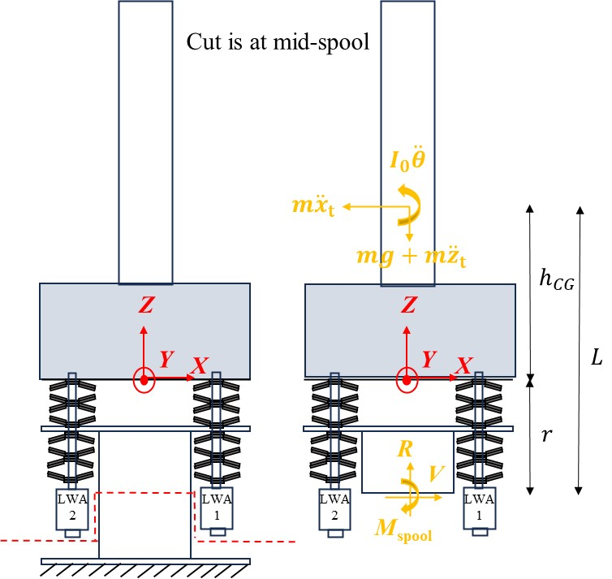
Figure 4-7
Free body diagram with mid-spool cut
Table 4-5
Summary of CVT inertia properties
Dimension | Description | Value
r | Distance between CVT base and mid spool | 11 in
L | Distance between CVT center of mass and mid spool | 46-1/16 in
l | Distance between CVT center of mass and center of rotation; this is obtained by fitting the equation $\ddot{x_{\text{g}}}+\ddot{θ}=\ddot{x_{\text{t}}}$ | 38 in

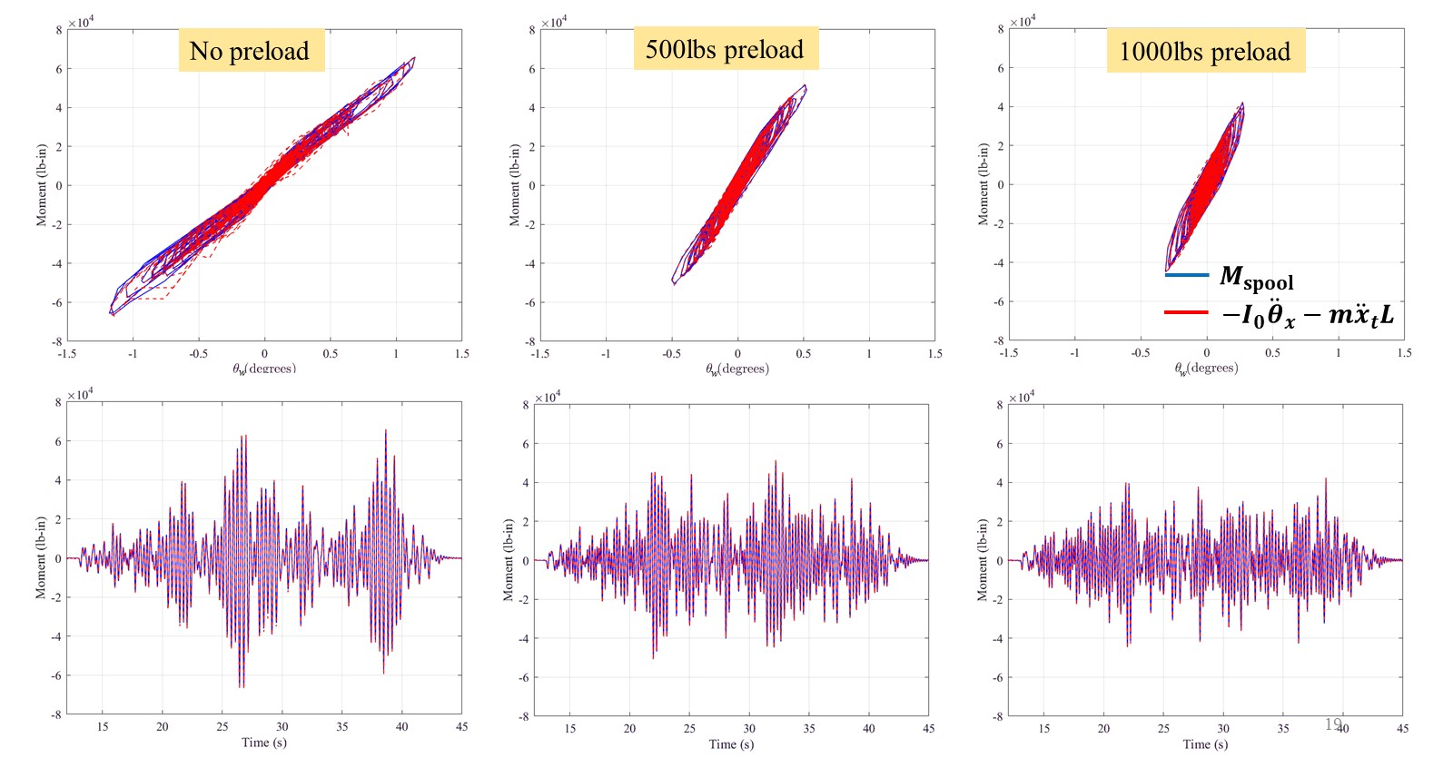
Figure 4-8
Correlation between the independent measurements, $M_{\text{spool}}$ and $-I_{0}\ddot{θ}-m\ddot{x_{\text{t}}}L$, demonstrating consistency for the 2 units of 2U2D configuration under 0.5g CERL motion in the X direction.

Next consider the free body diagrams shown in Figure 4-9. In this figure, F_{it} and F_{ib} stand for the force in the top and bottom washer stacks at corner i, and F_{i} for the force in the corresponding guide rod. Superscript “pre” denotes the preload component of these forces and Δ denotes the change due to the CVT weight and during dynamic response. Since each assembly of washers under preload is in equilibrium,
$F_{i\text{b}}^{\text{pre}}=F_{i\text{t}}^{\text{pre}}=F_{i}^{\text{pre}}$ (4-2)
Furthermore,
$F_{1}^{pre}=F_{2}^{pre}=F_{3}^{pre}{=F}_{4}^{pre}$ (4-3)
since all the assemblies are preloaded to the same level. Summing moments about the center of rotation O,
$\begin{matrix}M_{\text{spool}}-\left(F_{1}^{\text{pre}}+ΔF_{1}+F_{4}^{\text{pre}}+ΔF_{4}\right)b+\left(F_{2}^{\text{pre}}+ΔF_{2}+F_{3}^{\text{pre}}+ΔF_{3}\right)b \\ +\left(F_{1\text{t}}^{\text{pre}}-ΔF_{1\text{t}}-F_{4\text{t}}^{\text{pre}}-ΔF_{4\text{t}}\right)b-\left(F_{2\text{t}}^{\text{pre}}-ΔF_{2\text{t}}-F_{3\text{t}}^{\text{pre}}-ΔF_{3\text{t}}\right)b-Vr=0\end{matrix}$
Using (4-2) to cancel out the $F_{i}^{\text{pre}}$ and $F_{it}^{\text{pre}}$ terms, and substituting for V from (4-1),
$M_{\text{spool}}-\left(ΔF_{1}+ΔF_{4}\right)b+\left(ΔF_{2}+ΔF_{3}\right)b-\left(ΔF_{1\text{t}}+ΔF_{4\text{t}}\right)b-\left(ΔF_{2\text{t}}+ΔF_{3\text{t}}\right)b-m\ddot{x_{\text{t}}}r=0$ (4-4)
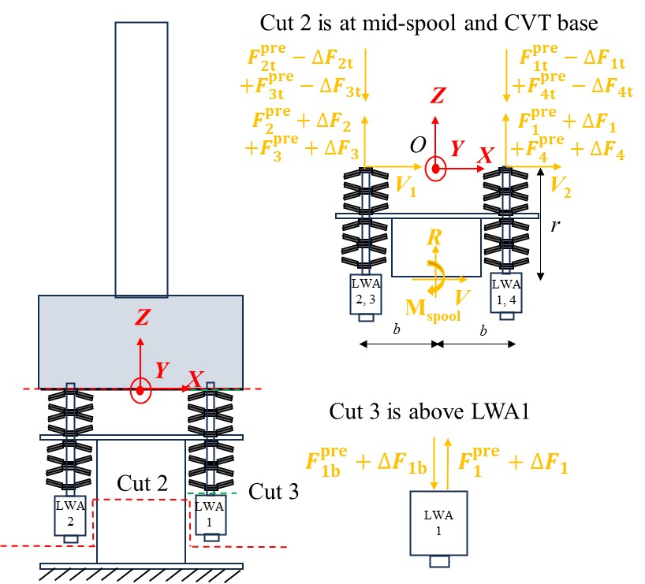
Figure 4-9
Free body diagrams relating moment measured at the spool with moment estimated using LWAs

A further assumption is made that
$ΔF_{i}=ΔF_{i\text{b}}=ΔF_{i\text{t}}$ (4-5)
This does not follow from equilibrium, but is taken to be true based on symmetry/compatibility of top and bottom stack deformations. Then equation (4-4) becomes
$M_{\text{spool}}=2\left(ΔF_{1}+ΔF_{4}-ΔF_{2}-ΔF_{3}\right)b+m\ddot{x_{\text{t}}}r$ (4-6)
Using equation (4-3), this can be further written as
$M_{\text{spool}}=\underset{M_{\text{CVT}}}{\underbrace{2\left(F_{1}-F_{2}-F_{3}+F_{4}\right)b}}+m\ddot{x_{\text{t}}}r$ (4-6)
where $F_{i}=F_{i}^{\text{pre}}+ΔF_{i}$ is the directly the force measured by LWA i. Verifying this relationship, which again involves multiple independent measurements, adds further confidence in the measured data for comparison with analysis. In particular, this confirms the thinking that the in situ behavior of the washer stacks can be determined from the materials testing machine measurements. This comparison is shown in Figure 4-10.
A final free body diagram, Figure 4-10, is considered in relation to the insulator base moment. The mass and mass moment of inertia of the insulator alone are not known, however its center of mass is assumed to be at mid-height. Summing the moments about the insulator base,
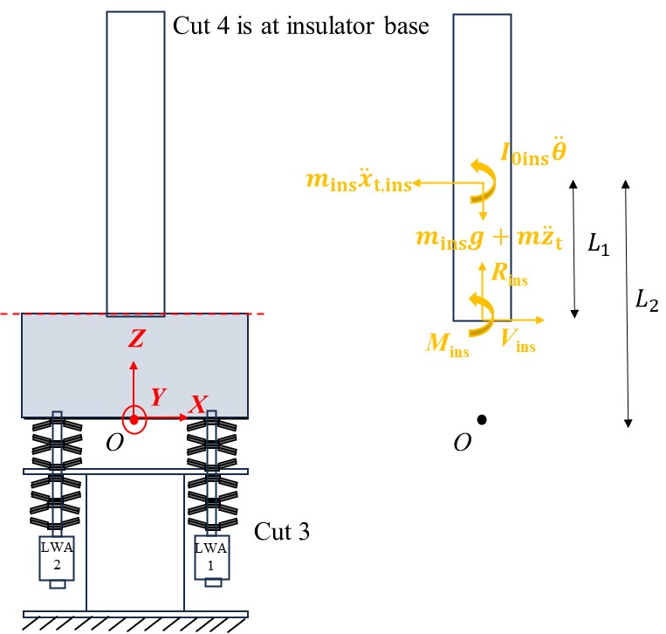
Figure 4-10
Free body diagram used to relate insulator base moment to measured accelerations; L₁ is the mid-height of the insulator, L₁ = in; L₂ = the distance from the center of rotation to the center of mass of the insulator, L₂ = in.

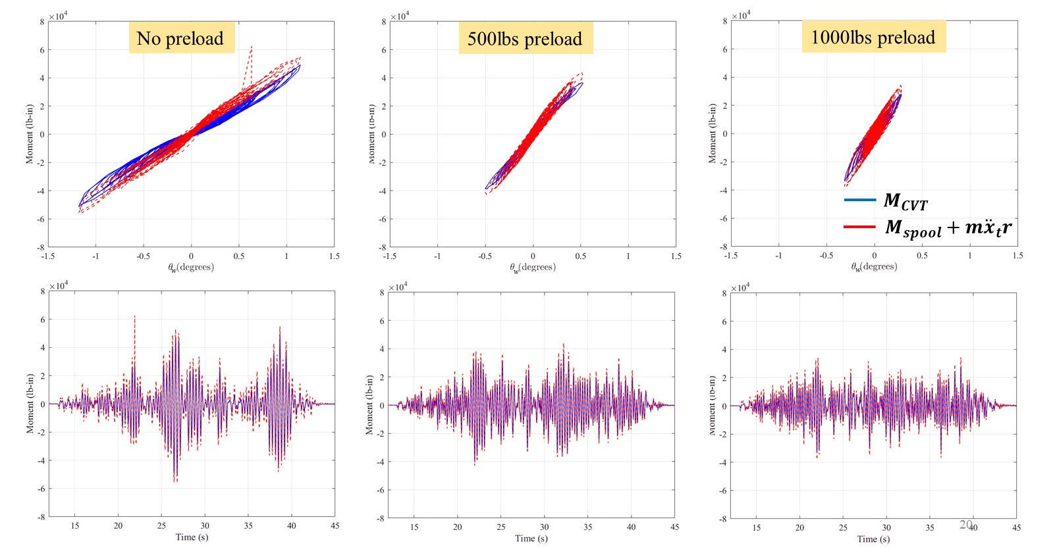
Figure 4-11
Correlation between $M_{\text{spool}}$ and $M_{CVT}$per equation (4-6) demonstrating consistency for the 2 units of 2U2D configuration under 0.5g CERL motion in the X direction.

$M_{\text{ins}}=-I_{0\text{ins}}\ddot{θ}-m_{\text{ins}}{\ddot{x}}_{t,ins}L_{1}$ (4-7)
Substituting the kinematics, ${\ddot{x}}_{t,ins}=\ddot{x_{\text{g}}}+L_{2}\ddot{θ}$,
$M_{\text{ins}}=-\underset{I_{\text{ins}}}{\underbrace{\left(I_{0\text{ins}}+m_{\text{ins}}L_{1}L_{2}\right)}}\ddot{θ}-m_{\text{ins}}L_{1}{\ddot{x}}_{g}$ (4-8)
The insulator mass, $m_{\text{ins}}$, and the net mass moment of inertia, $I_{\text{ins}}$ are known. Equation (4-8) is used to fit them to measure data. The fit values are $m_{\text{ins}}$=360/386.4 lb-s²/in (about 40% of the total mass of the CVT) and $I_{\text{ins}}$=3,500lb-in-s². These values are used when comparing analysis results to measured insulator base moment. The measured insulator base moments are shown in Figure 4-12 and Figure 4-13.

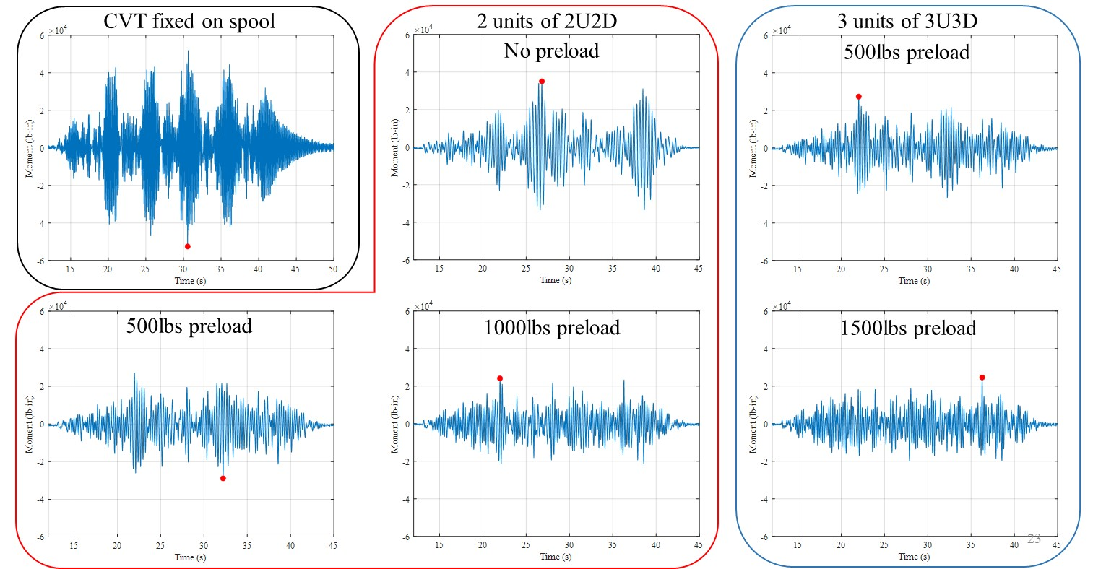
Figure 4-12
Measured insulator base moment for the different configurations for 0.5g CERL motion applied in the X direction

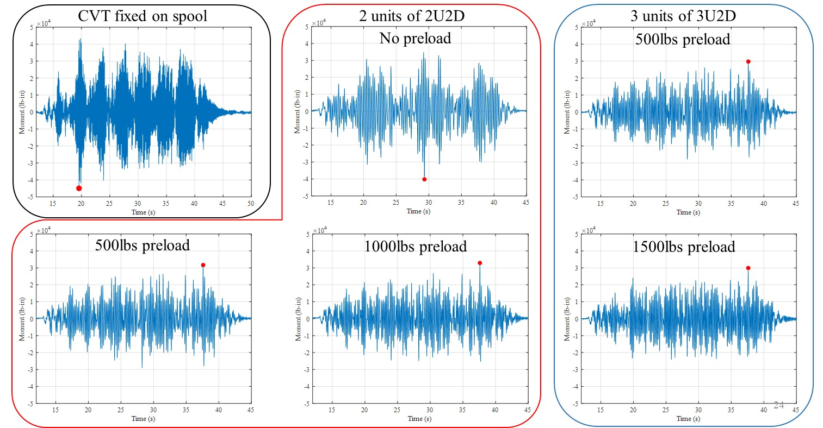
Figure 4-13
Measured insulator base moment for the different configurations for 0.5g CERL motion applied in the Y direction

Nonlinear modeling and analysis
In this chapter, a nonlinear model is developed for the CVT installed on Belleville washer stacks. The CVT is modeled as a rigid body, and a hysteretic model is used to represent the moment-rotation behavior resulting from the aggregate action of the washer stacks (the type of moment-rotation hysteretic behavior seen in the measurements of Figure 4-11).

From stack force-displacement to system moment-rotation
The moment-rotation hysteresis behavior can be obtained from the washer stack force-displacement response, whose measure was discussed in Chapter 3, using the process depicted in Figure 5-1. An example of this process is illustrated in Figure 5-2. The specific example shown in Figure 5-2 corresponds to a low preload (25% of flattening). In this condition, when the
Figure 5-1
Process to obtain moment-rotation behavior from washer-stack force displacement behavior
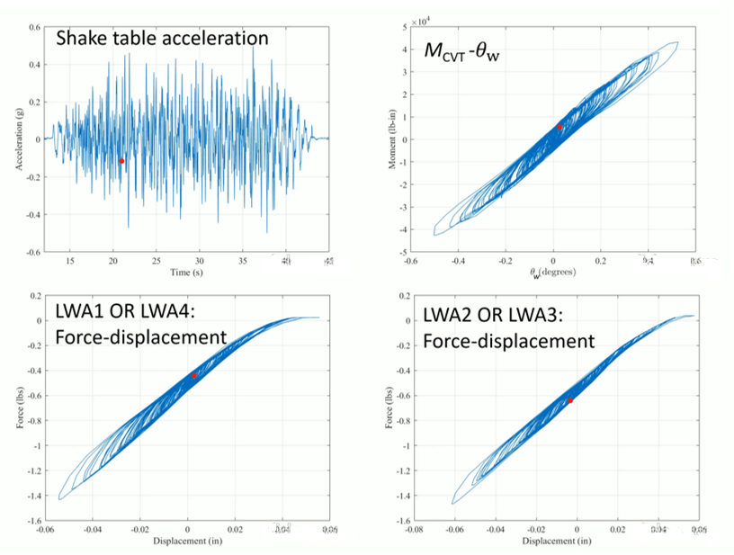
Figure 5-2
Example of constructing the moment-rotation behavior from the stack force-displacement behavior for 2 units of 2U2D.
washer stacks on one side reach the highest deformation (bottom left of Figure 5-2), the stacks on the other side relax entirely, losing preload (bottom right of Figure 5-2). The net effect is a softening of the moment-rotation behavior near the extremes (top right of Figure 5-2).

Modeling moment-rotation hysteresis
The moment-rotation behavior decomposed into two parallel components – one elastic and one hysteretic as illustrated in Figure 5-3. The split is given by
$M_{\text{CVT}}=Kθ_{\text{w}}+M_{\text{HYS}}$ (5-1)
for cases with sufficient preload as in Figure 5-3(a) and by
$M_{\text{CVT}}=K\tanh\left(αθ_{\text{w}}\right)+M_{\text{HYS}}$ (5-2)
for cases with insufficient preload as in Figure 5-3(b), the tanh function capturing the S shape.
The hysteretic component is represented using what is commonly referred to as the Bouc-Wen model [23, 24] (for a description of this model using notation similar to that used here, see [25, 26]), and is given by
$${\dot{M}}_{HYS}=k\left(1-{\left|\frac{M_{\text{HYS}}}{M_{\text{yield}}}\right|}^{N}\left(η+\left(1-η\right)\operatorname{sgn}\left(M_{\text{HYS}}{\dot{θ}}_{w}\right)\right)\right){\dot{θ}}_{w}$$
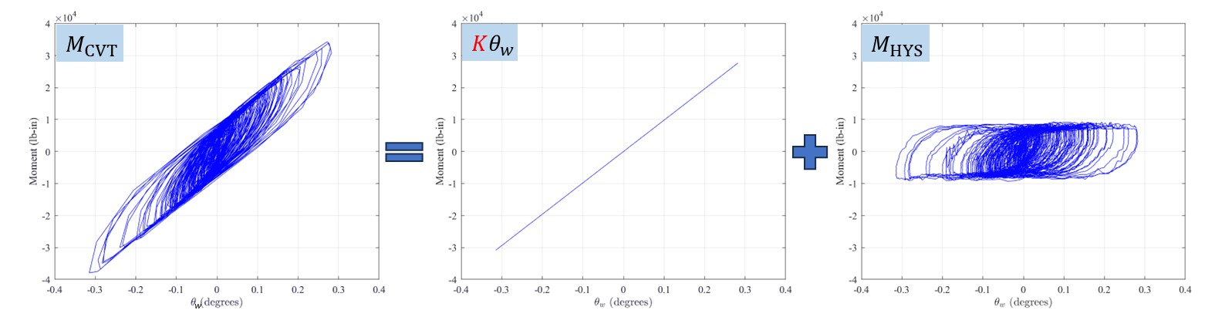
(a) Preload = 50% of flattening – elastic component is linear
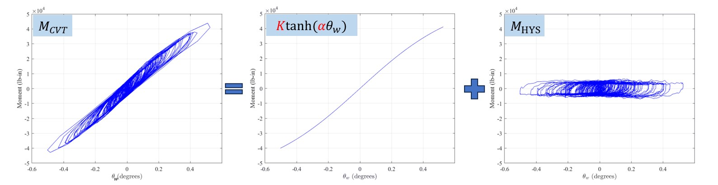
(b) Preload = 25% of flattening – elastic component is S-shaped due to the washer stacks on one side losing preload
Figure 5-3
Parallel decomposition of moment-rotation behavior into elastic and hysteretic components (example shown for 2 units of 2U2D).
where M_{yield} is the yield moment, and N and η are parameters that control the shape of the hysteresis. For an explanation of these parameters, see [27]. Figure 5-4 shows a comparison of the model with the measured moment-rotation behavior when the model is driven by the measured rotation of the CVT relative to the spool plate (θ_{w}).
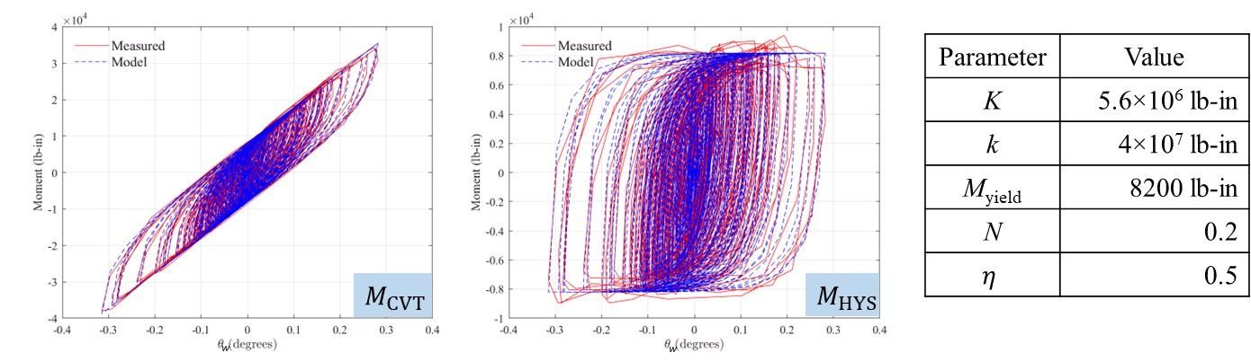
(a) Preload = 50% of flattening – elastic component is linear and given by equation (5-1)
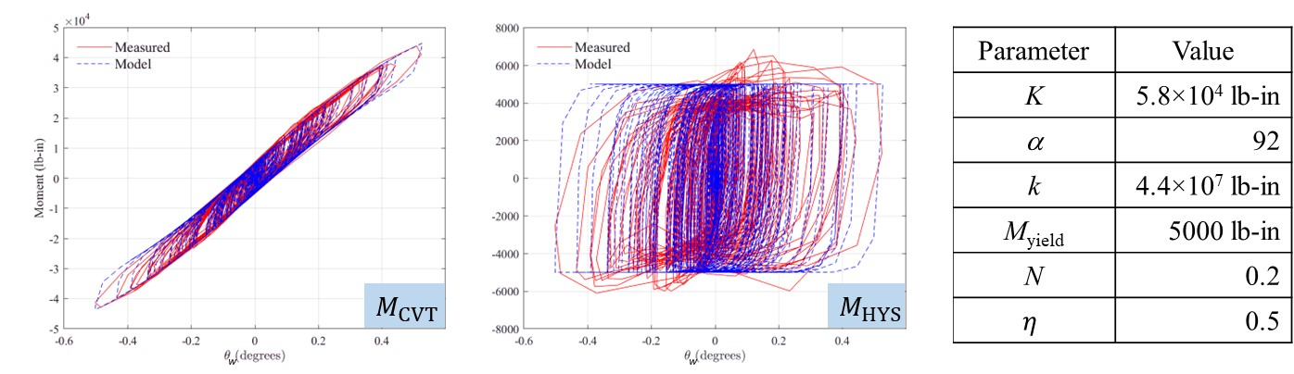
(b) Preload = 25% of flattening – elastic component is S-shaped and given by equation (5-2)
Figure 5-4
Comparison on model and measured moment-rotation behavior when the model is driven by the measured θ_{w} as input (example shown for 2 units of 2U2D).

Summary of nonlinear dynamic model

Analysis results

Equivalent linear modeling

Identifying equivalent frequency and damping ratio from measurements

Graphical determination of equivalent stiffness and damping ratio

Response-spectrum interpretation

Comparison with ASCE-7 procedures for base isolation

Summary and concluding remarks

Recommended analysis and design procedure

Outstanding research questions

REFERENCES
1. Couch, R. and R. Deacon, Procedures and criteria for increasing the earthquake resistance level of electrical substations and special installations. 1973, Agbabian Associates, El Segundo, CA (USA).
2. Cochran, R., Seismic Base Isolation of a High Voltage Transformer, in Electrical Transmission and Substation Structures 2015. 2015. p. 413-425.
3. Kempner Jr., L. and M.J. Riley. High voltage transformer base isolation. in Proceedings of the Canadian Association for Earthquake Engineering 2015.
4. Oikonomou, K., et al., Seismic isolation of high voltage electrical power transformers, in Techincal Report 2016.
5. Saadeghvaziri, M.A., et al., On Seismic Response of Substation Equipment and Application of Base Isolation to Transformers. IEEE Transactions on Power Delivery, 2010. 25(1): p. 177-186.
6. Blunt, N. The Difference Between Disc Springs and Belleville Washers. 2021.
7. Shigley, J.E. and C.R. Mischke, Standard handbook of machine design. 1996: McGraw-Hill.
8. Ashworth, G., The Disk Spring or Belleville Washer. Proceedings of the Institution of Mechanical Engineers, 1946. 155(1): p. 93-100.
9. Almen, J.O. and A. Laszlo, The uniform-section disk spring. Transactions of the American society of mechanical engineers, 1936. 58(4): p. 305-314.
10. Zhou, Y., et al., Modeling of disc springs based on energy method considering asymmetric frictional boundary. Thin-Walled Structures, 2023. 190: p. 110971.
11. Korytov, M., et al. Use of the Belleville spring package in the vibration protection mechanism of the operator’s seat. in Journal of Physics: Conference Series. 2022. IOP Publishing.
12. Maletta, C., L. Filice, and F. Furgiuele, NiTi Belleville washers: Design, manufacturing and testing. Journal of intelligent material systems and structures, 2013. 24(6): p. 695-703.
13. Solon Manufacturing Co. Belleville Spring Washer Applications & Solutions. 2024; Available from: https://www.solonmfg.com/washer-applications.
14. Fujita, T., et al. Fundamental study of three-dimensional seismic isolation system for nuclear power plants. in Proceedings, 11th world conference on earthquake engineering, Acapulco, Mexico. 1996.
15. Kitamura, S., et al., Experimental Study on Coned Disk Springs for Vertical Seismic Isolation System (K143). 2003.
16. Kitamura, S., S. Okamura, and K. Takahashi. Experimental Study on Vertical Component Seismic Isolation System With Coned Disk Spring. in ASME 2005 Pressure Vessels and Piping Conference. 2005.
17. Ramhormozian, S., et al., Stiffness-based approach for Belleville springs use in friction sliding structural connections. Journal of Constructional Steel Research, 2017. 138: p. 340-356.
18. Speicher, M., et al., Shape Memory Alloy Tension/Compression Device for Seismic Retrofit of Buildings. Journal of Materials Engineering and Performance, 2009. 18(5-6): p. 746-753.
19. Hill, K.E., The utility of ring springs in seismic isolation systems, in Department of Mechanical Engineering. 1995, University of Canterbury, Christchurch, New Zealand.
20. Ma, K., Y. Zhou, and D. Lu, Theoretical and experimental investigation on disc spring isolation system with loading rings. Soil Dynamics and Earthquake Engineering, 2023. 165: p. 107655.
21. IEEE, IEEE Recommended Practices for Seismic Design of Substations, in IEEE Std 693-1984. 1984. p. 1-13.
22. Key Bellevilles. Belleville Products Sample Catalog. 2024; Available from: https://keybellevilles.com/bellevilles/sampleCatalog.
23. Bouc, R. Forced vibrations of mechanical systems with hysteresis. in Proc. of the Fourth Conference on Nonlinear Oscillations, Prague, 1967. 1967.
24. Wen, Y.-K., Method for random vibration of hysteretic systems. Journal of the engineering mechanics division, 1976. 102(2): p. 249-263.
25. Sivaselvan, M.V. and A.M. Reinhorn, Hysteretic models for deteriorating inelastic structures. Journal of engineering mechanics, 2000. 126(6): p. 633-640.
26. Sivaselvan, M.V. and A.M. Reinhorn, Nonlinear structural analysis towards collapse simulation: A dynamical systems approach. 2004.
27. Constantinou, M.C. and M. Adnane, Dynamics of Soil-base-isolated-structure Systems: Evaluation of Two Models for Yielding Systems. Report 4. 1987: [Department of Civil Engineering], Drexel University.

Export Control Restrictions  Access to and use of this EPRI product is granted with the specific understanding and requirement that responsibility for ensuring full compliance with all applicable U.S. and foreign export laws and regulations is being undertaken by you and your company. This includes an obligation to ensure that any individual receiving access hereunder who is not a U.S. citizen or U.S. permanent resident is permitted access under applicable U.S. and foreign export laws and regulations.  In the event you are uncertain whether you or your company may lawfully obtain access to this EPRI product, you acknowledge that it is your obligation to consult with your company’s legal counsel to determine whether this access is lawful. Although EPRI may make available on a case by case basis an informal assessment of the applicable U.S. export classification for specific EPRI products, you and your company acknowledge that this assessment is solely for informational purposes and not for reliance purposes.  Your obligations regarding U.S. export control requirements apply during and after you and your company’s engagement with EPRI. To be clear, the obligations continue after your retirement or other departure from your company, and include any knowledge retained after gaining access to EPRI products.  You and your company understand and acknowledge your obligations to make a prompt report to EPRI and the appropriate authorities regarding any access to or use of this EPRI product hereunder that may be in violation of applicable U.S. or foreign export laws or regulations. | The Electric Power Research Institute, Inc. (EPRI, www.epri.com) conducts research and development relating to the generation, delivery and use of electricity for the benefit of the public. An independent, nonprofit organization, EPRI brings together its scientists and engineers as well as experts from academia and industry to help address challenges in electricity, including reliability, efficiency, affordability, health, safety and the environment. EPRI members represent 90% of the electric utility revenue in the United States with international participation in 35 countries. EPRI’s principal offices and laboratories are located in Palo Alto, Calif.; Charlotte, N.C.; Knoxville, Tenn.; and Lenox, Mass.  Together…Shaping the Future of Electricity
© 2019 Electric Power Research Institute (EPRI), Inc. All rights reserved. Electric Power Research Institute, EPRI, and TOGETHER…SHAPING THE FUTURE OF ELECTRICITY are registered service marks of the Electric Power Research Institute, Inc. | 10xxxxx

for example, by preloading washers of h/t of about 1.5 have nearly zero stiffness at flattening; so by preloading such washers to flattening and providing spacing to deformed beyond flattening, an isolation system with nearly zero frequency can be achieved (see for example 11. Korytov, M., et al. Use of the Belleville spring package in the vibration protection mechanism of the operator’s seat. in Journal of Physics: Conference Series. 2022. IOP Publishing.). Such approaches are not pursued in the present project but offer possibilities to consider in the future.

